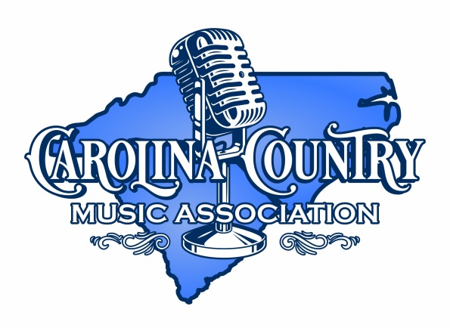
SONGWRITER REQUEST FORM &
VENUE PARTICIPATION AGREEMENT
Carolina Country Music Association
SweetTea@CarolinaCountryMusicAssociation.org
TODAY’S DATE: _______________________________________________________________________
VENUE NAME: ________________________________________________________________________
VENUE ADDRESS: _____________________________________________________________________
VENUE CITY/STATE/ZIP: ________________________________________________________________
VENUE CONTACT NAME: _______________________________________________________________
VENUE TELEPHONE: ___________________________________________________________________
VENUE EMAIL: ________________________________________________________________________
VENUE SEATING CAPACITY: ___________________

See reverse side for directions.
Directions: Select the two hour block(s) that you would be willing to host a performer by writing the letter of the performing style (or styles) that you believe would fit your venue from the list below:
Style A – Full band.
Style B – Songwriter Round. Multiple (2 to 6) songwriters, who perform in an acoustic style.
Style C – Individual acoustic performer.
 | Friday  May 6th, 2022 | Saturday  May 7th, 2022
2pm-4pm | Starts at 6pm
4pm-6pm | Starts at 6pm
6pm-8pm
8pm-10pm
10pm-12mid
12mid-2am
You are welcome to request multiple two hour blocks and multiple days; however, please note that this is a REQUEST form. By completing this form, you are requesting a performer. Performers and dates/times will be confirmed at a later date. All performances will be approximately 45-90 minutes.

Venue Participation Agreement:
- If your venue is selected to host a performer, you agree to use your best commercial efforts to promote your songwriter, your venue, and the festival.
- Venue provides sound, lighting, stage area that are appropriate to the Performing Style(s) selected in the schedule grid on the front of this Agreement.
- Performers are not guaranteed. Therefore, include the phrase “scheduled to appear…” in your marketing.
- The performance must be free for attendees. Venue cannot charge a “cover charge” or other fee to attend.
- Venue cannot sell merchandise of the singer/songwriter without prior permission of the singer/songwriter.

X_____________________________________
Venue Signature and Date

